YIELDVISION: ENSEMBLE MACHINE LEARNING APPROACH FOR PREDICTING SUGARCANE YIELD UNDER EL NIÑO CLIMATIC STRESS
Jenil Jani, Karina Kesur, Yug Mavani
Guide: Dr. Milind Nemade
Department of Artificial Intelligence and Data Science, K J Somaiya Institute of Technology, Mumbai, India

Abstract –
Sugarcane is one of India’s most important cash crops, and its long growth cycle exposes it to rainfall deficits and heat stress associated with El Niño–Southern Oscillation (ENSO) events. Conventional yield estimation relies on survey methods or on single models that rarely account for such climatic stress. This paper presents YieldVision, a machine-learning framework and web-based decision-support platform for sugarcane yield prediction. Four regressors – Linear Regression, Decision Tree, Random Forest and Support Vector Regression (SVR) – are trained on 120 multi-varietal field trials described by 11 agronomic, weather and management features and are combined into a soft-weighted Voting Regressor. On a 24-record hold-out set the ensemble achieves R² = 0.9993 and RMSE = 2.79 quintal/acre (about 0.69 t/ha); under 5-fold cross-validation it has the lowest RMSE (3.34 quintal/acre) and the most stable fold-wise R². The NOAA Oceanic Niño Index (ONI) is used to classify the ENSO phase and grade crop risk. The system is deployed with a FastAPI back end, a multilingual React dashboard and AI-generated advisories, and is suitable for farmers, sugar mills and policy planners.
Keywords
Sugarcane yield prediction, ensemble learning, Voting Regressor, Oceanic Niño Index, El Niño, FastAPI, React
I. Introduction
Sugarcane (Saccharum officinarum) anchors farm incomes and industrial output across Maharashtra, Uttar Pradesh and Karnataka, and supports the country’s sugar industry and renewable-ethanol programme [12]. Unlike annual cereals, the crop needs a growth window of roughly 10 to 18 months and requires consistent moisture, balanced nitrogen–phosphorus–potassium (NPK) nutrition and stable temperatures through germination, tillering, grand growth and maturation.
El Niño–Southern Oscillation is a recurring pattern of Pacific Ocean temperature variation that influences rainfall and temperature worldwide. NOAA expresses it through the Oceanic Niño Index (ONI), the 3-month running mean of sea-surface-temperature anomalies in the Niño 3.4 region [10]. During El Niño the Indian southwest monsoon is frequently weakened, which raises the risk of rainfall deficits and heat stress for rain-dependent crops [4], [6].
Existing yield-forecasting practice still depends on area-frame sampling, manual crop-cutting experiments or single statistical models such as standalone linear regression or an isolated decision tree. These methods treat climate as static local weather, ignore macro-climatic teleconnections such as ENSO, and therefore become unreliable in anomalous years. Many research prototypes also never reach farmers because they lack an accessible, multilingual interface.
This paper proposes YieldVision, which (i) benchmarks four regressors on a multi-varietal sugarcane trial dataset, (ii) combines them in a soft-weighted Voting Regressor validated by hold-out, 5-fold cross-validation and weight-sensitivity studies, (iii) uses the ONI as a climate-stress indicator for ENSO classification, risk grading and What-If analysis, and (iv) delivers the result as a full-stack, 12-language decision-support application. The rest of the paper reviews related work (Section II), describes the proposed system (Section III), its design (Section IV), and the implementation and results (Section V), and concludes in Section VI.
II. Related Work
Crop-yield prediction has been studied across agro-meteorology, remote sensing and applied machine learning. Van Klompenburg et al. [1] reviewed the literature and report that the most-used algorithms are regression, decision-tree, random-forest, neural-network and support-vector models, but that most studies rely on single models and do not consider El Niño effects. Singh et al. [2] summarise traditional machine learning, deep learning (LSTM, CNN) and ensemble techniques and find that ensemble and deep-learning approaches outperform single models, although the use of climate-anomaly data is limited. Das et al. [3] review machine-learning methods for sugarcane using climatic and soil parameters; the work shows improved forecasting but offers limited model comparison and little attention to El Niño stress.
Pedreira et al. [4] coupled the DSSAT-CANEGRO crop model with ENSO information and showed that ENSO phases measurably affect sugarcane yield and quality in Brazil, but the study is region-specific and mechanistic rather than machine-learning based. Patel et al. [6] document how El Niño episodes affect agricultural productivity in Gujarat, and a systematic review of AI for ENSO–crop modelling [5] finds that Random Forest, LSTM and CNN models show strong potential while scalability and local adaptation remain limitations. Deep networks also behave as opaque models and tend to overfit when only a few hundred curated records are available, as with multi-varietal sugarcane trials.
TABLE I — COMPARISON OF RELATED STUDIES
Ref. | Method / data | Limitation | Research gap
[1] | Review of LR, DT, RF, ANN, SVM with weather and soil data | Mostly single models; no El Niño consideration | Ensembles with climate-anomaly indices
[2] | Review of ML, deep learning and ensembles | Little use of ensembles and climate-anomaly data | ENSO indices with ensemble models
[3] | ML on climatic and soil parameters (sugarcane) | Limited model comparison; minimal El Niño focus | Multi-model comparison with El Niño features
[4] | DSSAT-CANEGRO crop simulation with ENSO | Brazil-specific; simulation, not ML | ML prediction combining ENSO with soil and weather

The reviewed work leaves one gap in common: very few frameworks combine multi-varietal agronomic field-trial benchmarks, a global climate-anomaly index and a soft-weighted ensemble of diverse regressors, and package them as an accessible, multilingual advisory platform. YieldVision addresses this gap, and the evaluation in Section V reports both the strengths and the limits of the approach.
III. Proposed System
YieldVision predicts sugarcane yield from agronomic, weather and management inputs using an ensemble of four regressors, and expresses the El Niño stress signal through ONI-based ENSO classification and risk grading. The yield unit used throughout the models is quintal/acre, converted to tonnes per hectare with the factor 0.2471.
A. Dataset and Features
The training and evaluation dataset is a regional benchmark of 120 multi-varietal sugarcane field trials with 11 input features and one target (Table II). The three cultivars (Co 86032, Co 0238 and CoM 0265) are perfectly balanced at 40 records each, and there are no missing values. A data-quality audit shows that 30 of the 120 records (25%) are exact duplicates of other records, which is addressed by the duplicate-aware validation in Section V.
TABLE II — FEATURES OF THE TRIAL DATASET
Group | Variables | Range / levels
Weather | Rainfall; mean temperature; sunshine hours | 800–1,970 mm; 26.5–35.2 °C; 6.8–9.3 h/day
Nutrients | Nitrogen, phosphorus, potassium | 100–243; 40–86; 50–112 kg/acre
Management | Crop duration; irrigation frequency; pest control | 320–422 days; 2–5 per month; yes/no
Categorical | Soil type; cultivar | 4 soil types; 3 cultivars
Target | Yield (quintal/acre) | 188.4–580.4; mean 400.8, SD 114.7

B. Preprocessing
Features pass through a Scikit-Learn ColumnTransformer. The nine numeric attributes are standardised as z = (x − μ)/σ, where μ and σ are the training-set mean and standard deviation, and the two categorical attributes are one-hot encoded, giving 16 input columns per model. The preprocessor is fitted on the training partition only (80:20 split, random_state = 42; 96 training and 24 test records), so no test information leaks into the scaling.
C. Base Regressors
The candidate suite covers parametric, non-parametric, kernel and bagging paradigms:
- Linear Regression (OLS): minimises the residual sum of squares; a fast, interpretable baseline.
- Decision Tree: recursively partitions the feature space by minimising within-region squared error (Scikit-Learn defaults, unpruned).
- Support Vector Regression: fits predictions inside an ε-insensitive tube using an RBF kernel [9] (C = 100, ε = 1.0).
- Random Forest: averages B = 100 decorrelated bootstrap trees to suppress variance [8].
D. Soft-Weighted Voting Regressor
To neutralise the blind spots of individual estimators, the final prediction is a normalised convex combination of the base predictions:
ŷ = Σ_{k} w_{k} ŷ_{k}, Σ_{k} w_{k} = 1 (1)
ŷ = 0.45·ŷ_{SVR} + 0.25·ŷ_{DT} + 0.20·ŷ_{RF} + 0.10·ŷ_{LR} (2)
The weights were set by judgement from the relative validation errors of the base models: the kernel and tree models, which fit the trial data most closely, receive the largest shares, while the linear model keeps a small share as a stable, low-variance trend component. Alongside the prediction the application reports an inter-model agreement score, bounded to 88–99.6% and computed as 99.4 − 110·σ_{m}/ŷ, where σ_{m} is the standard deviation of the four base predictions. This is a measure of disagreement, not a statistical confidence interval.
E. ENSO Classification and Risk Grading
The ENSO phase is derived from the ONI value and, together with two management variables, determines the risk grade shown on the dashboard, in the What-If simulator and in the advisory text (Table III). In the current implementation the ONI is an application-level input rather than a column of the 120-record dataset, which carries no year attribute; the trained regressors use the 11 features of Table II.
TABLE III — ONI-BASED ENSO CLASSIFICATION AND RISK RULES
ONI condition | ENSO state | Risk-level rule
ONI ≥ +0.5 °C | El Niño | Moderate if irrigation ≥ 3 per month, otherwise High
−0.5 < ONI < +0.5 °C | Neutral | Stable if pest control applied, otherwise Moderate
ONI ≤ −0.5 °C | La Niña | Stable

F. Advantages of Proposed System
- Robust Prediction: a diverse ensemble is the most stable estimator across validation splits.
- Climate Awareness: ENSO phase and risk grading give an early-warning cue for El Niño seasons.
- What-If Planning: farmers can compare management and weather scenarios against a baseline.
- Accessibility: 12-language interface, Farmer Guidance mode and plain-language advisories.
- Transparency: per-model predictions, feature importances and benchmark metrics are exposed to the user.
- Graceful Degradation: advisories and the front end keep working if the external AI service or back end is unavailable.
IV. System Design and Architecture
A. System Architecture
YieldVision is a decoupled, four-layer platform (Fig. 1). The data ingestion layer consolidates the 120-record trial benchmark, district-wise sugarcane production statistics (1997–2015), the seasonal ONI series and user inputs. The machine-learning and ensemble engine wraps the ColumnTransformer and the four regressors plus the Voting Regressor in Scikit-Learn pipelines serialised with Joblib. The back-end API is a Python FastAPI application (Uvicorn, Pydantic) exposing prediction, What-If, climate, model-performance, report and chat endpoints; it persists every prediction and scenario in SQLite (with an equivalent Supabase/PostgreSQL schema). The front end is a React 18 + TypeScript single-page application built with Vite and Tailwind CSS.
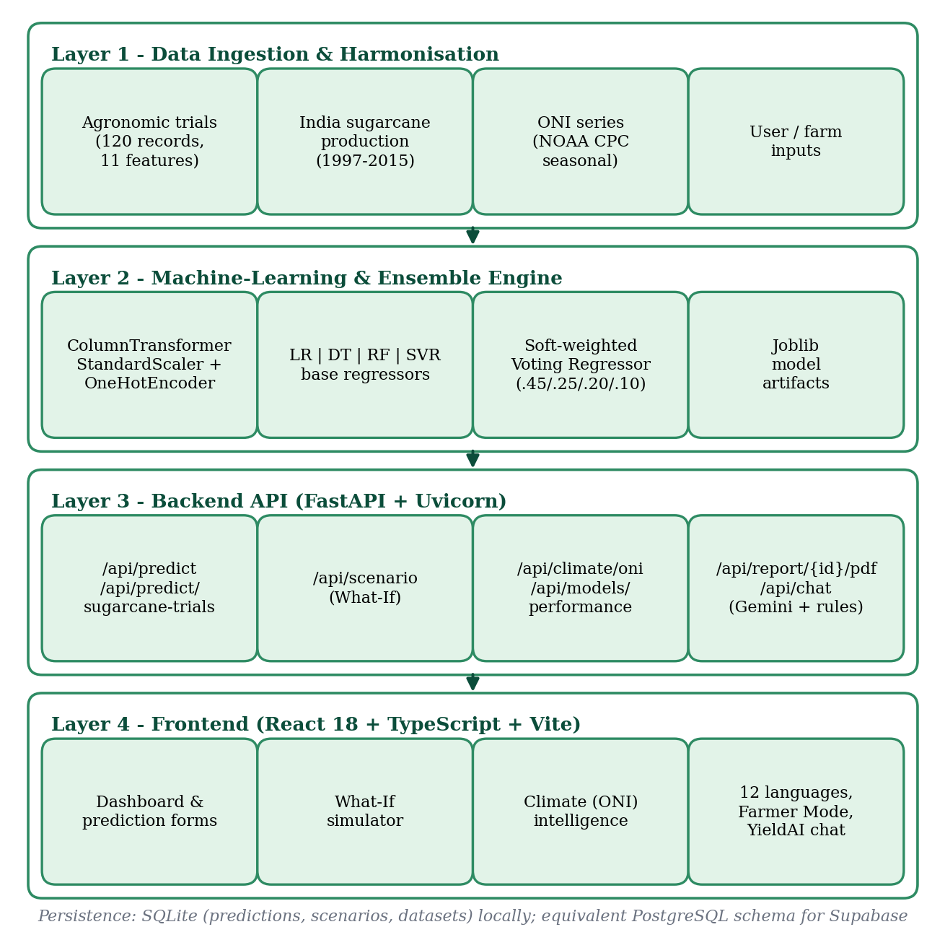
Fig. 1. Four-layer system architecture of YieldVision.
B. El Niño Teleconnection
Fig. 2 summarises the causal chain that motivates the use of the ONI: warm Pacific sea-surface temperatures weaken the Indian monsoon, producing rainfall deficits and heat stress, which cause soil-moisture stress in cane fields and ultimately lower tonnage and sucrose recovery [4], [6].
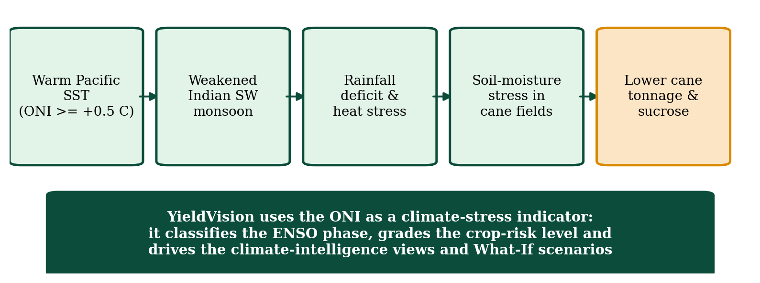
Fig. 2. El Niño teleconnection pathway affecting sugarcane yield.
C. Workflow
- Load the 120-record trial dataset and separate the 11 features from the target.
- Build the ColumnTransformer (scaling and one-hot encoding).
- Split the data 80:20 and fit the preprocessor on the training partition.
- Train Linear Regression, Decision Tree, Random Forest and SVR.
- Combine them in the Voting Regressor with weights 0.45/0.25/0.20/0.10.
- Evaluate with MAE, RMSE and R² (hold-out, 5-fold CV) and serialise the models.
- At request time: predict, convert to t/ha, compute the agreement score, derive the ENSO state and risk level from the ONI, and return the advisory.
D. Software Stack
Python 3.10+ with Scikit-Learn, NumPy, Pandas and Joblib implements the machine-learning pipeline; FastAPI, Uvicorn and Pydantic provide the REST service; ReportLab renders PDF reports; the Google Gemini API generates natural-language advisories with a built-in rule-based fallback; and a custom TypeScript engine provides 12 languages (English, Hindi, Marathi, Gujarati, Punjabi, Bengali, Tamil, Telugu, Kannada, Malayalam, Odia and Assamese).
V. Implementation and Results
This section describes the implementation of YieldVision and the results of its evaluation on the trial benchmark. Performance is assessed with MAE, RMSE and R²; all errors are in quintal/acre (multiply by 0.2471 for t/ha).
A. Implementation
Preprocessing and each regressor are wrapped in a single Scikit-Learn Pipeline so that identical transformations are applied during training and inference, with a fixed random seed (42) and metrics stored in metadata.json. The FastAPI service loads the five Joblib pipelines at start-up; for each request it validates the input, obtains the five predictions, converts to t/ha, computes the agreement score, derives the ENSO state and risk level, generates insights and stores the record. The /api/scenario endpoint runs the model on the baseline and on modified inputs and returns the change. The React dashboard offers prediction, a What-If simulator, model-performance and climate-intelligence pages, a Farmer Guidance mode with voice input, benchmark presets and PDF export.
B. Experimental Setup
All models are trained on the 120-record benchmark using the fixed 80:20 split (96 training, 24 test records). Because a 24-record test set is small, three further studies were added: 5-fold cross-validation, duplicate-aware validation and a weight-sensitivity study. The mean yield of the dataset is 400.8 quintal/acre, so an RMSE of 2.79 corresponds to about 0.7% of the mean.
C. Results
Table IV and Fig. 3 compare the models. Linear Regression has by far the largest error (RMSE 16.82, R² = 0.9754) because it cannot model the non-linear interaction between soil, water and nutrient inputs. SVR has the lowest hold-out error (RMSE 1.98, R² = 0.9997), and the Voting Regressor (RMSE 2.79, R² = 0.9993) ranks third on this split, clearly better than Random Forest and Linear Regression. On 24 test records the differences among SVR, the Decision Tree and the ensemble are small relative to sampling noise, so cross-validation is used to rank them.
TABLE IV — HOLD-OUT (n = 24) AND 5-FOLD CV RESULTS (QUINTAL/ACRE)
Model | MAE | RMSE | R² | CV RMSE | CV R²
Linear Regression | 11.31 | 16.82 | 0.9754 | 13.22 | 0.9866
Decision Tree | 1.87 | 2.48 | 0.9995 | 3.74 | 0.9989
Random Forest | 3.20 | 4.26 | 0.9984 | 6.57 | 0.9967
SVR (RBF) | 1.58 | 1.98 | 0.9997 | 3.53 | 0.9990
Voting Regressor | 2.12 | 2.79 | 0.9993 | 3.34 | 0.9991

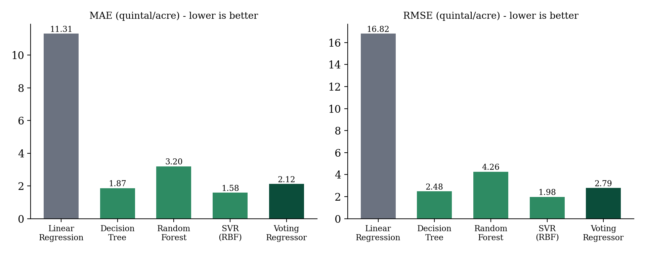
Fig. 3. MAE and RMSE of the base estimators and the Voting Regressor on the hold-out set (lower is better).
Under 5-fold cross-validation the Voting Regressor has the lowest RMSE (3.34), ahead of SVR (3.53) and the Decision Tree (3.74), and the smallest fold-to-fold spread in R² (SD 0.0003 against 0.0008 for SVR and the Decision Tree; Fig. 4). Combining diverse models therefore does not beat every single model on every split, but it is consistently near the best and the most stable, which is the property needed on unseen farms. This supports the hypothesis that a soft-weighted ensemble generalises more stably than any single constituent model.
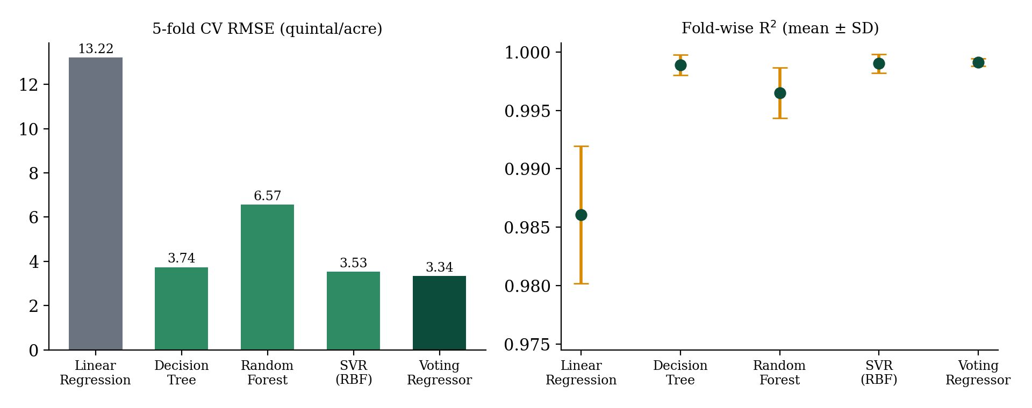
Fig. 4. 5-fold cross-validation RMSE and fold-wise R² of the five models.
D. Duplicate-Aware Validation and Weight Sensitivity
Because 30 of the 120 records are exact duplicates, a random split can place a record in the test fold while its twin sits in the training fold, which flatters flexible models. Table V repeats the cross-validation after removing the duplicates (90 unique records) and with grouped folds that keep identical records together. Errors rise for every model, confirming a modest leakage effect, but the ranking is stable: the Voting Regressor has the lowest error with duplicates removed (RMSE 4.83, R² = 0.9982) and is within 0.13 quintal/acre of the best model with grouped folds.
TABLE V — CROSS-VALIDATED RMSE UNDER THREE PROTOCOLS
Model | All 120 | 90 unique | Grouped
Linear Regression | 13.22 | 13.43 | 13.55
Decision Tree | 3.74 | 5.07 | 4.23
Random Forest | 6.57 | 9.24 | 9.50
SVR (RBF) | 3.53 | 5.95 | 3.67
Voting Regressor | 3.34 | 4.83 | 3.80

To check that the weights are sensible, the ensemble was re-evaluated under 5-fold cross-validation with equal weights (RMSE 4.56) and with an alternative weighting (RF 0.40, SVR 0.25, DT 0.20, LR 0.15; RMSE 4.17). The implemented weights give the lowest error (RMSE 3.34), about 36% and 25% below the two alternatives. The weights are still hand-set; learning them by stacking is a natural improvement.
E. Feature Importance
Random-Forest importances show that agronomic management dominates: nitrogen (19.9%), crop duration (18.5%), phosphorus (15.8%), potassium (13.7%) and pest control (13.4%) together account for about 81% of the importance, while the three weather variables share about 17%. In the trial design, weather and nutrient variables are strongly correlated with yield (r = 0.85–0.89), so this is a ranking of predictive usefulness, not of causal effect.
F. What-If Analysis and ONI-Based Risk Grading
Table VI shows how the deployed Voting Regressor responds when single inputs of a baseline farm (Co 86032 on alluvial soil, 1,450 mm rainfall, 32.5 °C, N-P-K = 180-65-80 kg/acre, three irrigations per month, pest control applied) are changed.
TABLE VI — WHAT-IF SCENARIOS (DEPLOYED VOTING REGRESSOR)
Scenario | Yield (quintal/acre) | Change
Baseline (Co86032, Alluvial) | 484.3 | –
Rainfall −30% (1015 mm) | 479.0 | −1.1%
Temperature +2.5 °C (35.0) | 488.8 | +0.9%
Drought: rain −30% and +2.5 °C | 482.3 | −0.4%
Nitrogen 120 kg/acre | 455.6 | −5.9%
No pest control | 350.7 | −27.6%
Irrigation 2 per month | 471.5 | −2.6%
Variety CoM0265 | 486.2 | +0.4%

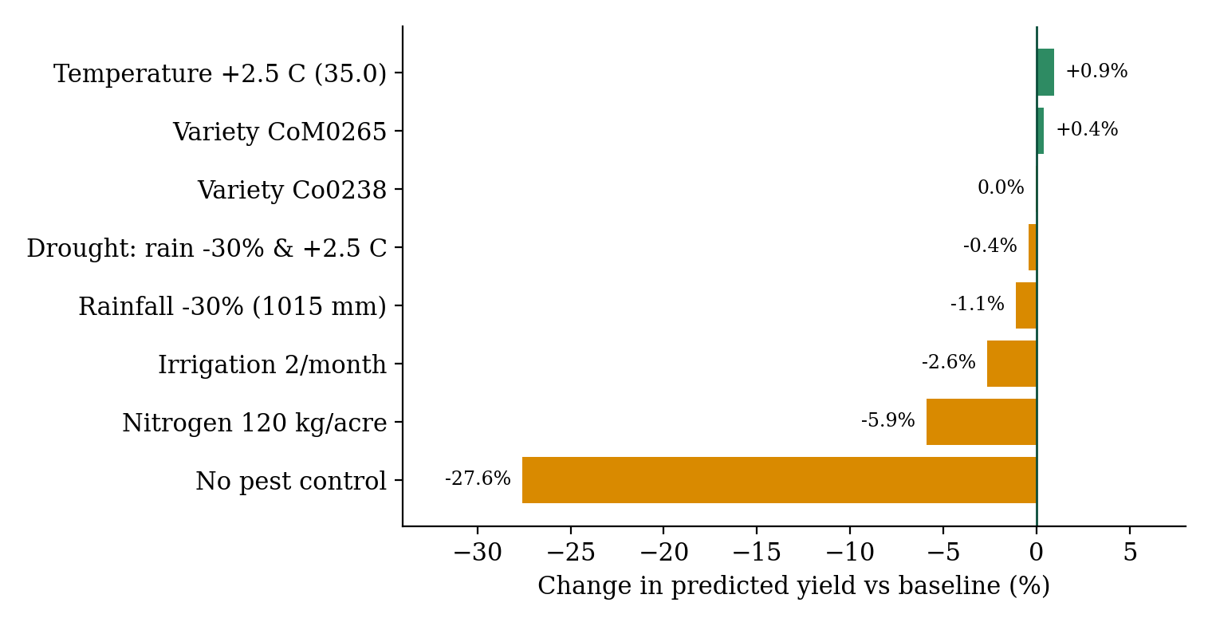
Fig. 5. Percentage change in predicted yield for single-factor What-If scenarios.
Management variables dominate the response: omitting pest control lowers the prediction by 27.6% and cutting nitrogen from 180 to 120 kg/acre lowers it by 5.9%, both in the agronomically expected direction. The weather response is weak (a 30% rainfall reduction changes the prediction by only −1.1%). This is a limitation of the training data, not a finding about sugarcane physiology: the trials span 800–1,970 mm of rainfall and 26.5–35.2 °C without deliberately stressed plots, so the regressors have not learnt a drought or heat-stress response. For this reason the El Niño stress signal is conveyed through the ONI-based risk grading of Table III rather than through the regressors. For example, an ONI of +1.80 °C with three irrigations per month and pest control gives a Moderate risk, which escalates to High when irrigation drops to two per month; a Neutral ONI of −0.35 °C with pest control is graded Stable.
G. Observations
- The Voting Regressor is the most dependable estimator rather than the winner on every split.
- Hold-out residuals of the ensemble are centred on zero (mean −0.005, SD 2.79) with a largest absolute error of 6.99 quintal/acre, showing no systematic bias between high- and low-yielding plots.
- The system is easy to run locally (Node.js 18+ and Python 3.10+) and can be extended to other crops with new data.
H. Limitations
- Small, regular dataset: with 120 records (25% duplicated), the very high R² describes in-distribution performance on trial plots, not field-level accuracy on commercial farms.
- ONI is not a learned input: it enters through rule-based ENSO classification and risk grading; its quantitative effect on prediction error could not be estimated because the benchmark has no year or ONI attribute.
- Weak weather response: the regressors should not be used to extrapolate beyond the trained rainfall and temperature ranges.
- Agreement score is not a confidence interval, and the ensemble weights and hyper-parameters were hand-set rather than tuned.
- Advisory text generated by a language model should be reviewed by agronomists before being treated as a formal recommendation.
VI. Conclusion
In this paper, YieldVision – a machine-learning system for sugarcane yield prediction under variable climatic conditions – has been proposed, implemented and evaluated. It integrates agronomic field-trial data, weather and management inputs and El Niño (ONI) climate information, addressing a main limitation of conventional forecasting: the omission of teleconnected climate-stress indicators.
Four model families were trained and compared, and a soft-weighted Voting Regressor achieved R² = 0.9993 and RMSE = 2.79 quintal/acre (about 0.69 t/ha) on the hold-out set. Under 5-fold cross-validation it had the lowest RMSE (3.34 quintal/acre) and the most stable fold-wise R², and it remained among the best models when duplicate records were controlled. Its weights outperform equal weighting by about 36% in RMSE. The honest reading of the evidence is that the ensemble is the most dependable estimator, and that the ONI currently acts as a risk-grading and scenario input rather than a learned feature.
The work was delivered as a full-stack web application with a FastAPI server, SQLite/Supabase persistence, a responsive React front end, Gemini-generated advisories with a rule-based fallback, PDF reports and a 12-language interface. Applications include farm advisory, crop insurance, government policy planning, sugar-mill procurement planning and climate research. Future work includes combining the district-wise production statistics with the official NOAA ONI series to learn the ENSO effect, collecting more non-duplicated trials, learning ensemble weights by stacking, adding prediction intervals, and integrating IoT soil sensors and Sentinel-2 satellite imagery for real-time forecasting.
References
[1] T. Van Klompenburg, A. Kassahun and C. Catal, “Crop yield prediction using machine learning: A systematic literature review,” Computers and Electronics in Agriculture, vol. 177, Art. no. 105709, Oct. 2020.
[2] Singh et al., “Machine Learning for Crop Yield Prediction: A Comprehensive Review,” 2025.
[3] Das et al., “Sugarcane Yield Prediction Using Machine Learning: A Review,” 2025.
[4] J. G. S. Pedreira, I. M. Fattori Jr., M. dos S. Vianna and F. R. Marin, “Assessing the impact of El Niño–Southern Oscillation on sugarcane yield and quality in Brazil’s South-Central Region using the DSSAT-CANEGRO model,” Theoretical and Applied Climatology, vol. 157, no. 1, pp. 1–13, 2026.
[5] U. H. Wannasingha et al., “Advances in artificial intelligence to model the impact of El Niño–Southern Oscillation on crop yield variability,” MethodsX, vol. 15, Art. no. 103650, 2025.
[6] H. R. Patel et al., “El Niño episodes and agricultural productivity in Gujarat,” Technical Report No. 01/2014-15, Anand Agricultural University, Gujarat, 2014.
[7] F. Pedregosa et al., “Scikit-learn: Machine learning in Python,” Journal of Machine Learning Research, vol. 12, pp. 2825–2830, 2011.
[8] L. Breiman, “Random forests,” Machine Learning, vol. 45, no. 1, pp. 5–32, 2001.
[9] A. J. Smola and B. Schölkopf, “A tutorial on support vector regression,” Statistics and Computing, vol. 14, no. 3, pp. 199–222, 2004.
[10] NOAA Climate Prediction Center, “Oceanic Niño Index (ONI),” Cold & Warm Episodes by Season. [Online]. Available: https://origin.cpc.ncep.noaa.gov/products/analysis_monitoring/ensostuff/ONI_v5.php
[11] B. Huang et al., “Extended Reconstructed Sea Surface Temperature, Version 5 (ERSSTv5),” Journal of Climate, vol. 30, no. 20, pp. 8179–8205, 2017.
[12] Standing Committee on Consumer Affairs, Food and Public Distribution (17th Lok Sabha), “Sugar Industry in India – A Review,” Government of India, 2022–23.

